All The Best to everyone.ol

Companies you can search:-

**ANYWHERE REf-TESTviBY SNAPDEAL ??**

**Why re-test?**

EdgeVerve, Walmart, Opera, Knowlarity, Qualcomm, Citrix, Bridgely, Samsung, Adobe, MicroSoft, CouponDunia, CitiGroup, Flipkart, Hikari Tsushin, Carwale, Visa, Target, Morgan Stanley, Saplabs, Ebay, Grabhouse, Headout, Relevant E solutions(Roposo.com), AmEx, Intel, Saavn

Queries:

**DELL?? LM**

**CAPITAL ONE ??**

**QU**

**ALCOMM interview???**

AXIS BANK???

ARM??

Carthero??

**Nvidia at IITB??**

**Rambus chip? Sandisk?**

AppDynamics?? -- IIT B PLEASE POST QUESTIONS?? Added other doc :)

**Box8??**

**Fico?? Hi**

**P,j**

**General Motors??**

**Indus Valley Partners??**

**i3??**

**MasterCard??**

**Novartis??mat.monstermat.monsteredfn vgy SFC gxerghgvh the V, Hz Hz**

Deloitte ??

Amex??

**UBER??**

NETAPP QUESTIONS?

Opera Solutions??????

Tower Research Questions at IITB?

OLA?drive

Free Scale questions??????

PROPTIGER questions????

**EXL ?**

**General Motor? Steelwedge? Target Corp ??**

**TATA STEEL??? Smartprix??fto**

**VMWARE ?? Fractal?? FICO?**

**Ebay??**

***JIVOX ??***

Opera solution(software)

iit delhi

time duration-90min

10-os(1 mark each)

10-sql(1 mark each)

15-c/data structure(2 mark each)

EdgeVerve @ IIT(Roorkee)

Loc.: Bangalore

CTC: 16-17LPA Date:16th Sept

Q1

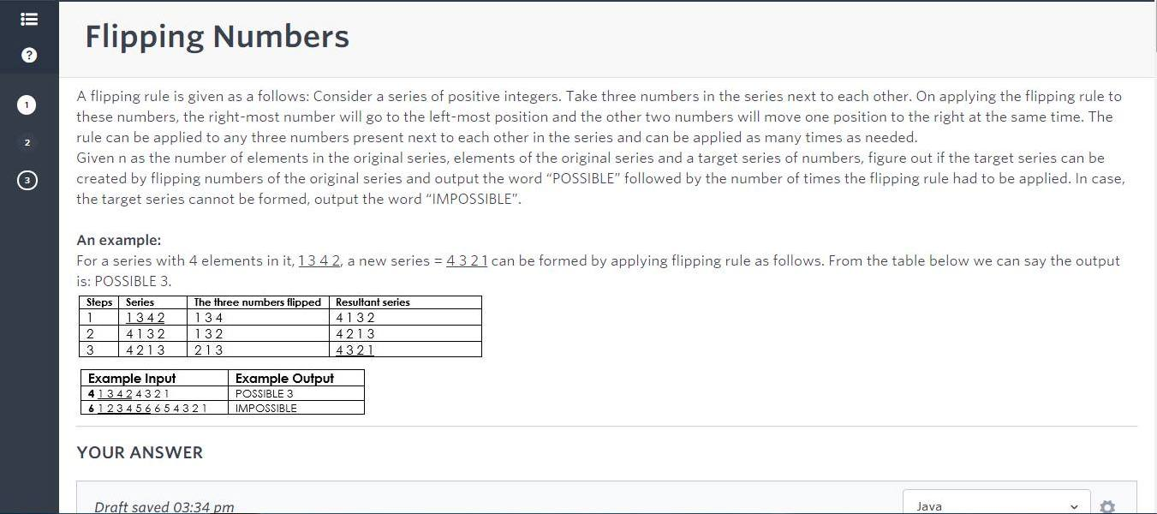

///how to solve this, any solution???

the best i can think of is recursion any better approach??

What is wrong with this solution?

Given Series S

Target Series T

Search for T[0] in S, say at index i. Do rotations till S[i] comes at S[0] and recur for remaining n-1 elements of S and T.

Q2 Solution anybody????code

I can think of a solution - Keep an array to get indices of any number.   
If given sequence is 201, then array b = {1,2,0} - a[0] = 1 as 0’s index is 1

Now iterate thru the sequence. For every number i, for all j ST i-j>=0 && i+j <n, check whether i-j and i+j lie on different sides of this number. If yes, we have an ap.  
But this is O(n^2) and n is 10^4.. 10^8 .. Don’t know if it accepts or gets a TLE.

Q3\_1

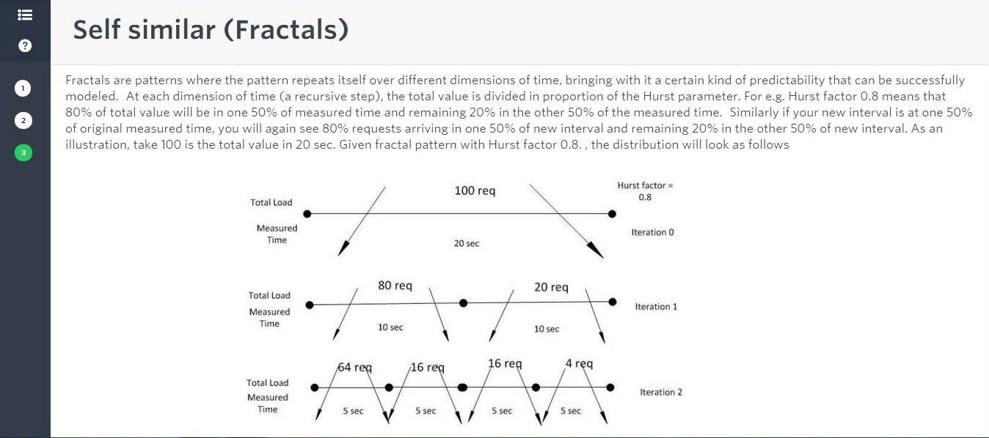

Q3\_2

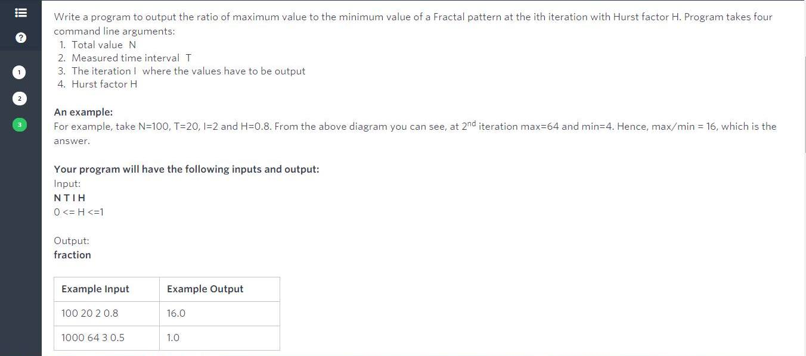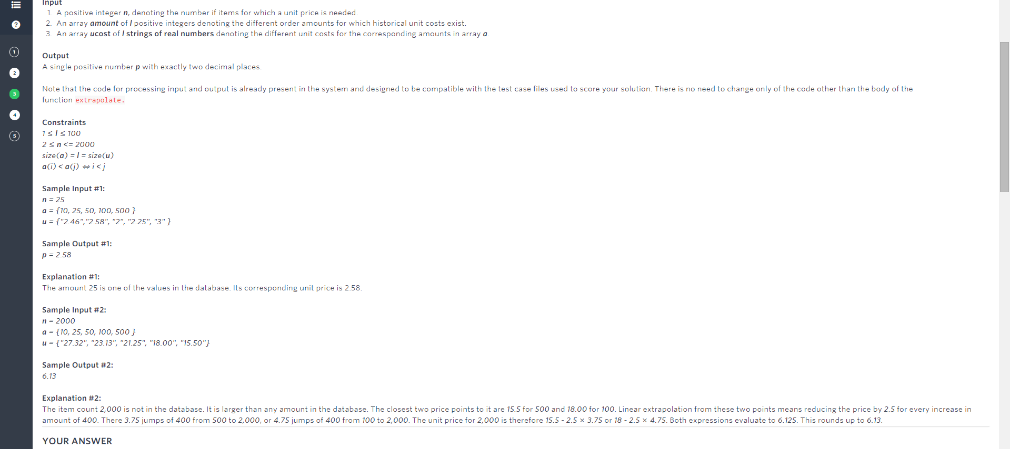

Is it just (max(p,1-p)/min(p,1-p))^n ?

--->Yes

*EdgeVerve @ IIT Madras*

05/10/2015

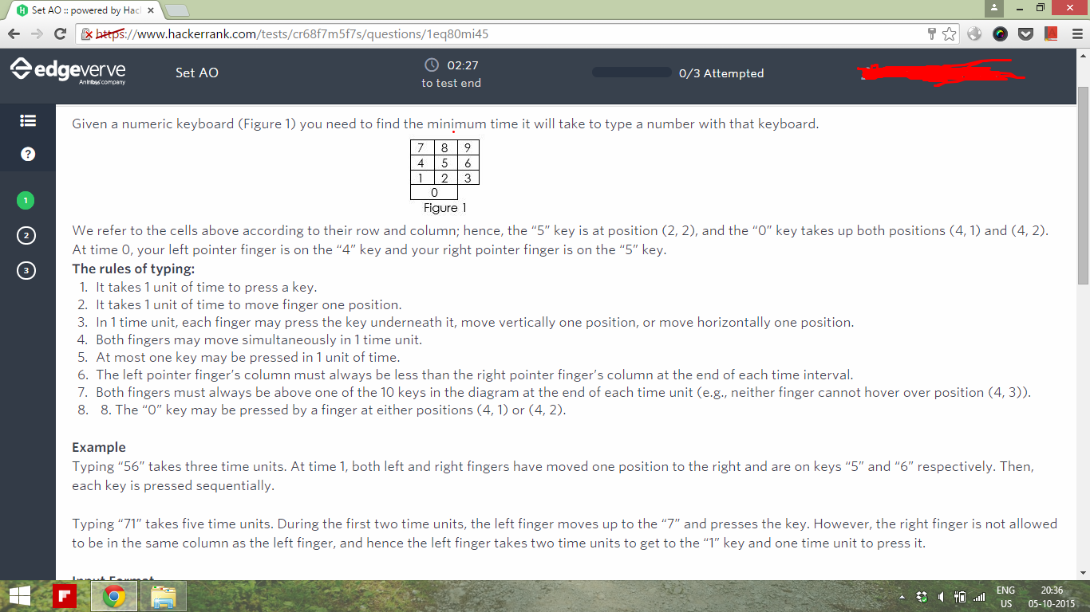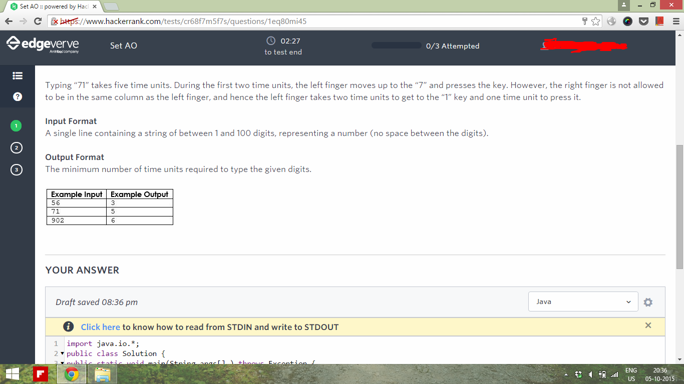

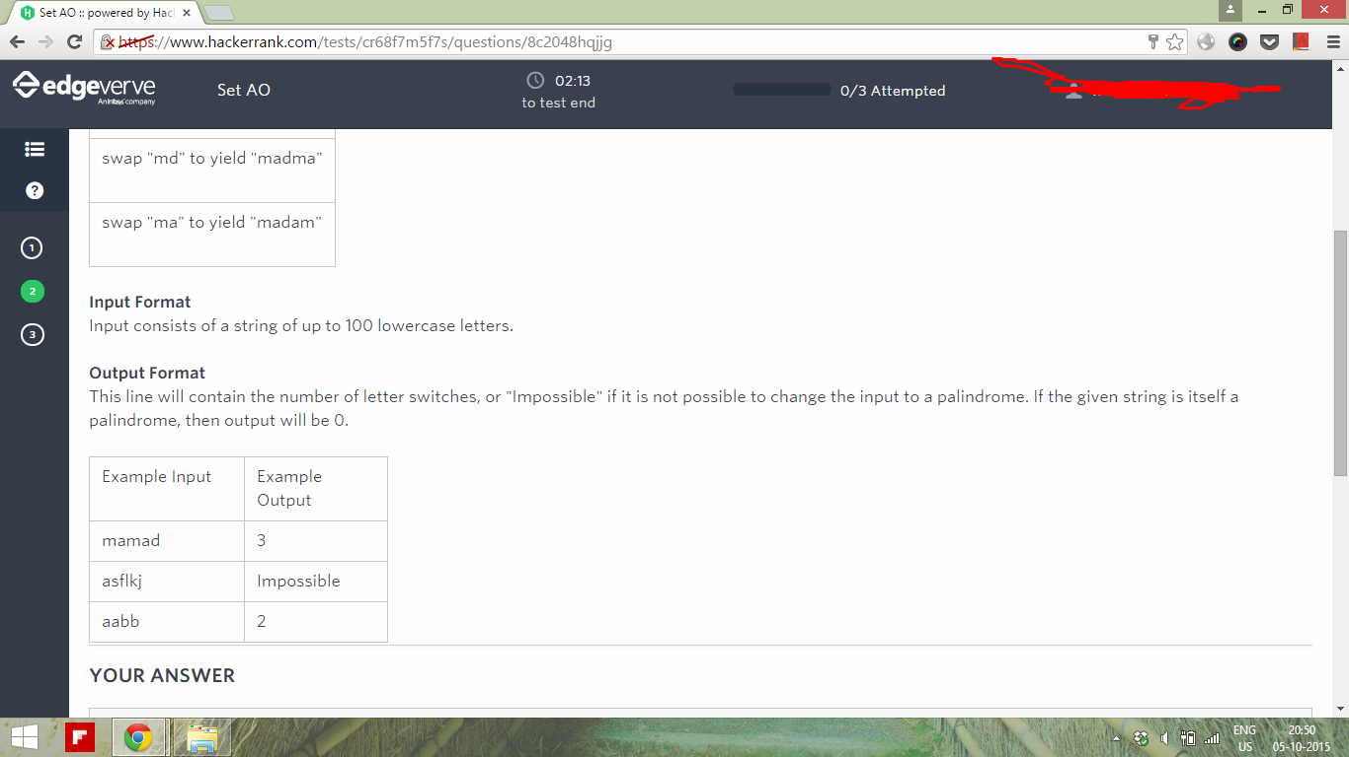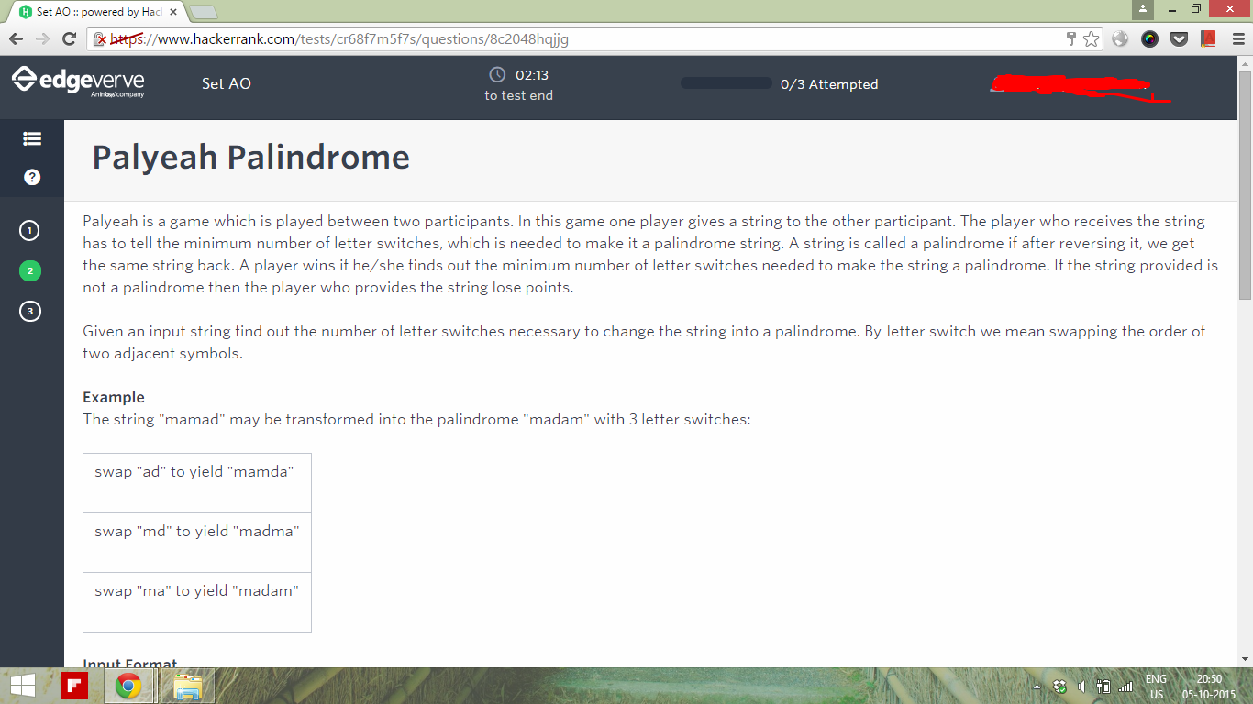

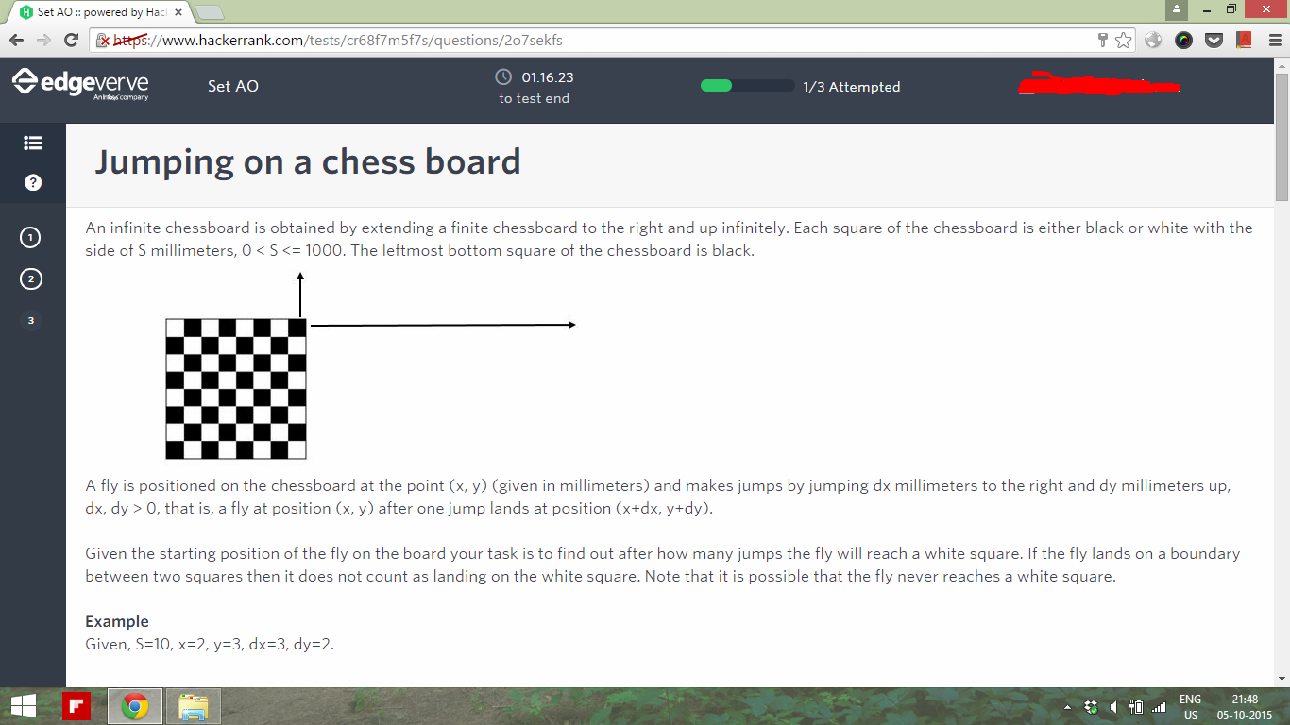

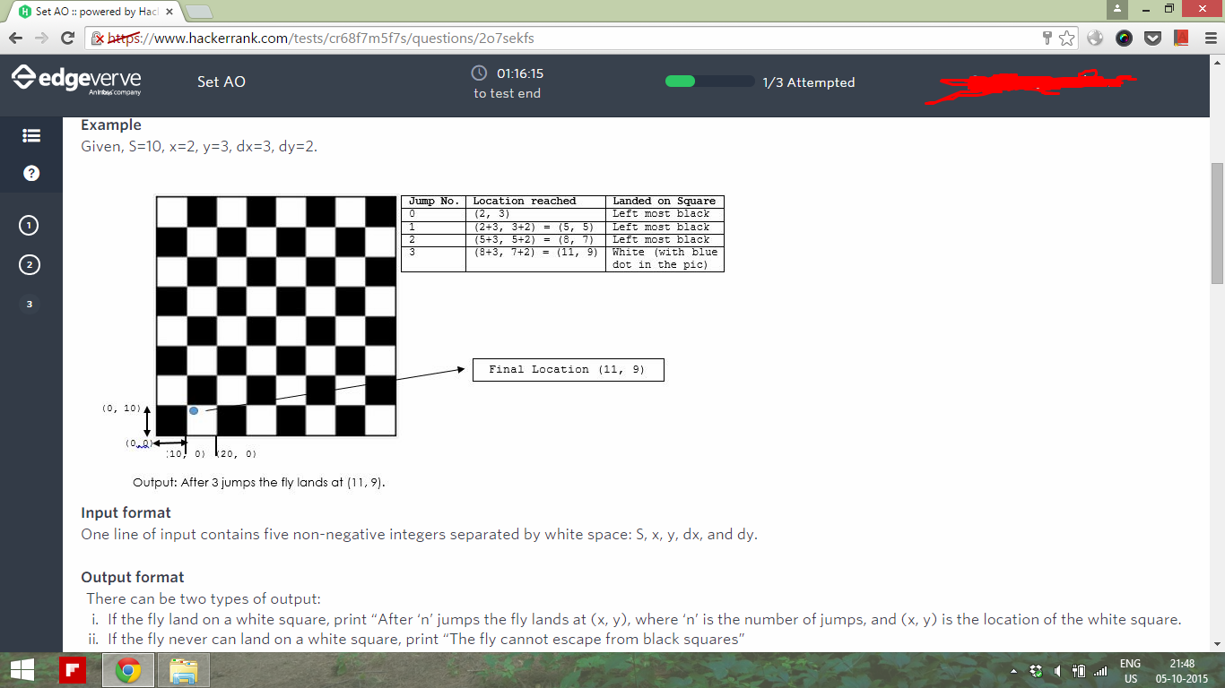

*EdgeVerve @ IIT Delhi*

Date- 27-10-2015 (3 questions on a question paper and code was required to submitted via mail)

1. (15 marks Long but simple question)

Question: Given an expression in terms of -,+ and \*, evaluate it. But each of the term in expression is mentioned in different base. So effectively you had to convert all the of the numbers first into base 10, evaluate the expression and output the result in a “given” base. Use any inbuilt functions you want!

1. (10 marks) Minimum swaps required to convert a string into palindrome
   1. Input: mamad   
      Output: 3
   2. Input: aabb  
      Output: 2
   3. Input: lsdjfajlj  
      Output: 0
2. (10 marks) Given an integer n, find the largest p such that for some integer a,   
   such that n = a^p
   1. <http://stackoverflow.com/questions/29376069/lexographically-smallest-path-in-a-nm-grid>Input: 64  
      Output: 6
   2. Input: -128  
      Output: 7
   3. Input: -729000000  
      Output: 3

Walmart Labs @ IIT Roorkee walmart

16-10-2015 (90 min)

CTC:19

// Where are the questions??? Please Update!!!

→ The solutions to questions have been submitted. Don’t worry, next year during the paper, the question will come back again.

A very simple probability quer - 1/x estion. - Answ(you’ll know x when you see the question)but many faced problem because they didn’t know how to set precision 10. Use ‘fixed setprecision’.

[http://stackoverflow.com/questions/3947867/find-the-least-number-of-coins-frequired-that-can-make-any-change-from-1-to-99-ce](http://stackoverflow.com/questions/3947867/find-the-least-number-of-coins-required-that-can-make-any-change-from-1-to-99-ce)

**Walmart Labs @ IITK**

10 mcq’s (1 mark each) and 3 coding questions (100 marks each) in 1.5 hours (but I heard there are individual cutoffs for both sections)

Given a mathematical expression, check whether the parenthesis used in that expression are balanced or not.Possible parenthesis used can be {},[],() only.Eg.(2+3)/4\*[9+{8\*5}].

* mcq’s mostly on OS and data structures - thread properties, implementation of queue using 2 stacks, property of assembly code, double pointer declaration, expected number of triangles in graph with 8 vertices with prob of edge existing = 0.5 , Definition of P, NP-complete and NP-hard etc.

Coding questions:

1. (though the divide and conq. method is more elegant and easier to code)

Suppose the grid is nxm. Find min of matrix. Suppose it is (i,j)th elem ent. Now the remaining path can only be in matrix1 of size (ixj) (left top matrix of i,j th element) and matrix2 of size (n-i,m-j) (bottom right matrix of i,j th element). Recur for them.

or the exact question is: <http://www.careercup.com/question?id=5149445358354432>

array elements are char or numbers? if numbers then what is meant by lexicographic order ?? If elements are 9,10 then {9,10} is smaller than {10,9} but if we have to form number then 109 is smaller than 910. Please explain..

1. <http://www.geeksforgeeks.org/find-the-largest-rectangle-of-1s-with-swapping-of-columns-allowed/> (slight modification: we also had to output the minimum number of swaps to achieve the largest area),
2. Define, f(x) = gcd(1,x) + gcd(2,x) +.... + gcd(x,x)

Input:

a[], multiple pairs of (i,j) (i<=j) (of the form “C i j”)output:

f(a[i]) + f(a[i+1]) + ….. + f(a[j]) for each case

There was also something about updation of the array a[] (test case of the form “U i j”) but I don’t remember.

Walmart Labs @ IIT BHU

Platform : Hacker earth

Questions : 3

1. Given a string s containing only numbers 0 to 9. You are allowed to do m operations on the string, find the lexicographically largest string that can be generated. An operation is defined as swapping of two adjacent characters.

Input Format : First line contains the string and second contains m.

Ex.74

2159467

5

Output:

9521467

2. Given a rooted tree of n nodes. Each node being numbered 1 to n and each has a value associated with it. The root of the tree is given as r. You have to perform two types of queries on the tree. First query is represented as " sum a" where you have to find the sum of all values of nodes in the subtree rooted at a (i.e. sum of values of all nodes going down from a and including the value at node a).

Second query is represented as "update a v" where you have to increment the value of node a by v.

Input format :

First line contains n and r, where n is the number of nodes and r is the root of the tree. Next line contain n integers denoting the value of each node. Then n-1 lines follow, each containing two space separated integers u and v, such that there exists an edge between u and v (note that it was not specified who is the parent u or v). Followed by a number q denoting the number of queries. In the next q lines are the queries.

3. A variation of <http://www.spoj.com/problems/AGGRCOW/>

Walmart Labs @ IIT Bombay

Date: 1-Nov-2015

10 mcq’s (2 mark each) and 3 coding questions(20,30,40 marks)

Time: 1.5 Hr

platform: hackerEarth

**Ten MCQs: (answers are marked in Green)**

1. Three concurrent processes X, Y, and Z execute three different code segments that access and update certain shared variables. Process X executes the P operation (i.e., wait) on semaphores a, b and c; process Y executes the P operation on semaphores b, c and d; process Z executes the P operation on semaphores c, d, and a before entering the respective code segments. After completing the execution of its code segment, each process invokes the V operation (i.e., signal) on its three semaphores. All semaphores are binary semaphores initialized to one. Which one of the following represents a deadlock-free order of invoking the P operations by the processes?

|  |  |
| --- | --- |
|  | **A.**X: P(a)P(b)P(c) Y: P(b)P(c)P(d) Z: P(c)P(d)P(a) |
|  | **B. X: P(b)P(a)P(c) Y: P(b)P(c)P(d) Z: P(a)P(c)P(d)** |
|  | **C.**X: P(b)P(a)P(c) Y: P(c)P(b)P(d) Z: P(a)P(c)P(d) |
|  | **D.**X: P(a)P(b)P(c) Y: P(c)P(b)P(d) Z: P(c)P(d)P(a) |

1. A thread is usually defined as a "light weight process" because an operating system (OS) maintains smaller data structures for a thread than for a process. In relation to this, which of the following is TRUE?

|  |  |
| --- | --- |
|  | **A.**On per-thread basis, the OS maintains only CPU register state |
|  | **B.The OS does not maintain a separate stack for each thread** |
|  | **C.**On per-thread basis, the OS does not maintain virtual memory state |
|  | **D.**On per-thread basis, the OS maintains only scheduling and accounting information |

1. Minimum number of queues needed to implement the priority queue?

A.1  **B. 2**  c. 3 d. 4

1. Consider the label sequences obtained by the following pairs of traversals on a labeled binary tree. Which of these pairs identify a tree uniquely ?

(i) preorder and postorder  
(ii) inorder and postorder  
(iii) preorder and inorder  
(iv) level order and postorder

1. (i) Only
2. **(ii) and (iii)**
3. (iii) Only
4. (iv) OnlyQuestions
5. A complete n-ary tree is a tree in which each node has n children or no children. Let I be the number of internal nodes and L be the number of leaves in a complete n-ary tree. If L = 41, and I = 10, what is the value of n?

1. 6
2. 3
3. 4
4. **5**
5. Which tree has minimum height on one subtree and maximum height on other subtree
6. Fibonacci
7. **Parse**
8. Binary
9. Binary Search Tree
10. What will be output if you will compile and execute the following c code?

void main(){

int i=320;

char \*ptr=(char \*)&i;

printf("%d",\*ptr);

}

1. 320
2. 1
3. **64**
4. Compiler Error

8) Code snippet on inheritance

9) & 10) Code snippets on pointers

**Three Coding Questions:**

1. **Variation of** [**http://www.geeksforgeeks.org/find-number-of-islands/**](http://www.geeksforgeeks.org/find-number-of-islands/) **(40 Marks)**

**The given matrix was a map of army of Souron. armies are scattered in map.**

**You need to find number of armies and size of each army. The soldiers presence will be indicate by 1 in cell. If a soldier is adjacent to other soldier in same row and column as his, then both are in same army.**

**INPUT:** NxM ( N rows and M columns)

next N lines contain M values each

last line contains n=m=0

5 4

0 1 0 0

1 1 1 1

1 1 1 1

0 1 1 0

1 0 0 1

0 0

**OUTPUT**: Total Number of different armies

Size followed by number of armies of that size (in ascending order)

3

1 2

11 1

**Explanation:** As you can clearly observe from graph that upper and middle part contains an island of eleven ones. Last row contains two isolated 1s.hence total armies are 3 and Two size-1 armies and One size-11 army.

1. **Given book types as ‘t’ and books of each type. You have to arrange each type books in stacks. The number of books in each stack must be same. Output the stack size such that number of stacks be minimum. (20 Marks)**

**INPUT**

3

84, 90, 120

**OUTPUT:**

6

**Explanation:**

There are 3 types of books. 84 of type-1, 90 of type-2, 120 of type-3.

Output is 6 ( each stack is of size 6)

***Solution Approach:*** *6 = GCD(84,90,120).*

**3) Given two positions on MxN Matrix: A & B.**

**Output minimum number of steps to swap their positions: (30 Marks)**

**Conditions:**

**1) They cannot swap their position in one turn.**

**2) They cannot be at one cell simultaneously ( was not given in description But it was obvious)**

**INPUT:** M and N.

Position of A and B as x1,y1,x2,y2

2 2

0 0 1 1

**OUTPUT:**

2

**Explanation:** Given positions are:

A \_

\_ B

As they cannot swap in one go. A will move to (0,1) and B will move to (1,0) in single step. Next They will move to desired positions. Hence 2 steps.

-------------------------------------------------------------------------------------

**KLA Tencor @ IIT-B (total 60 Minutes)**

**Algorithm Engineer**

**23-Nov-2015**

**2 coding Questions**

1. count Connected components

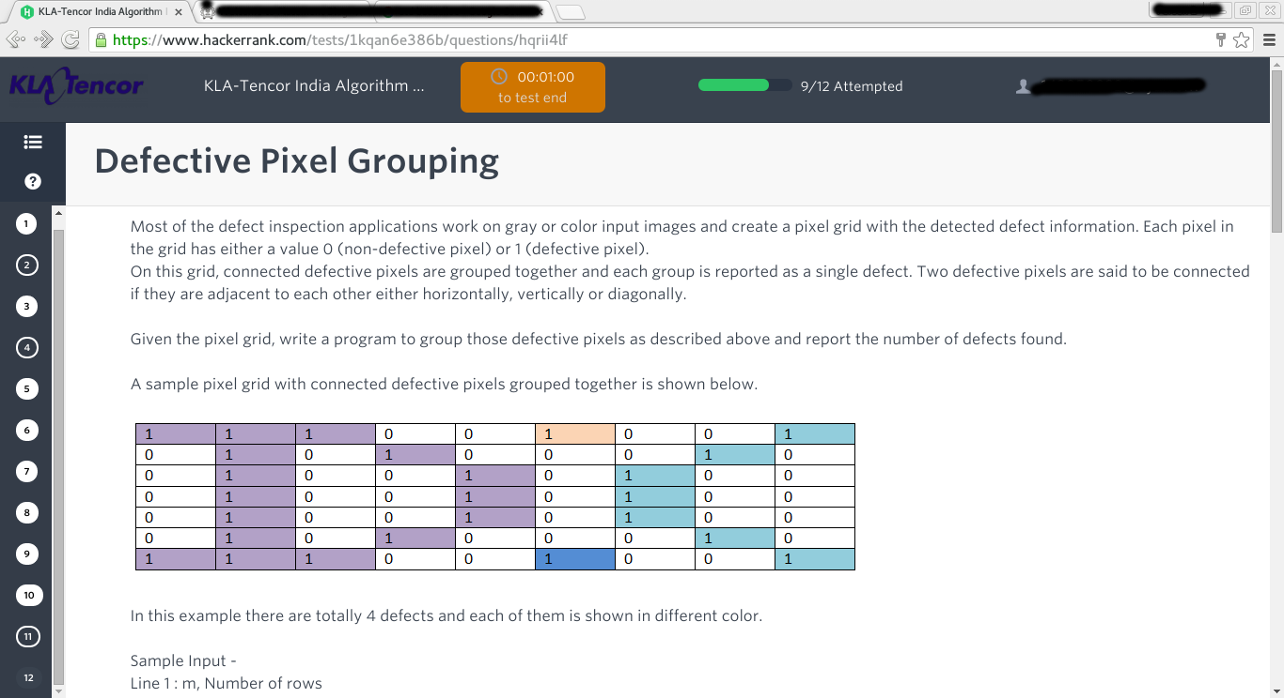

1. does two given string has exact count for each alphabet (ignore case)

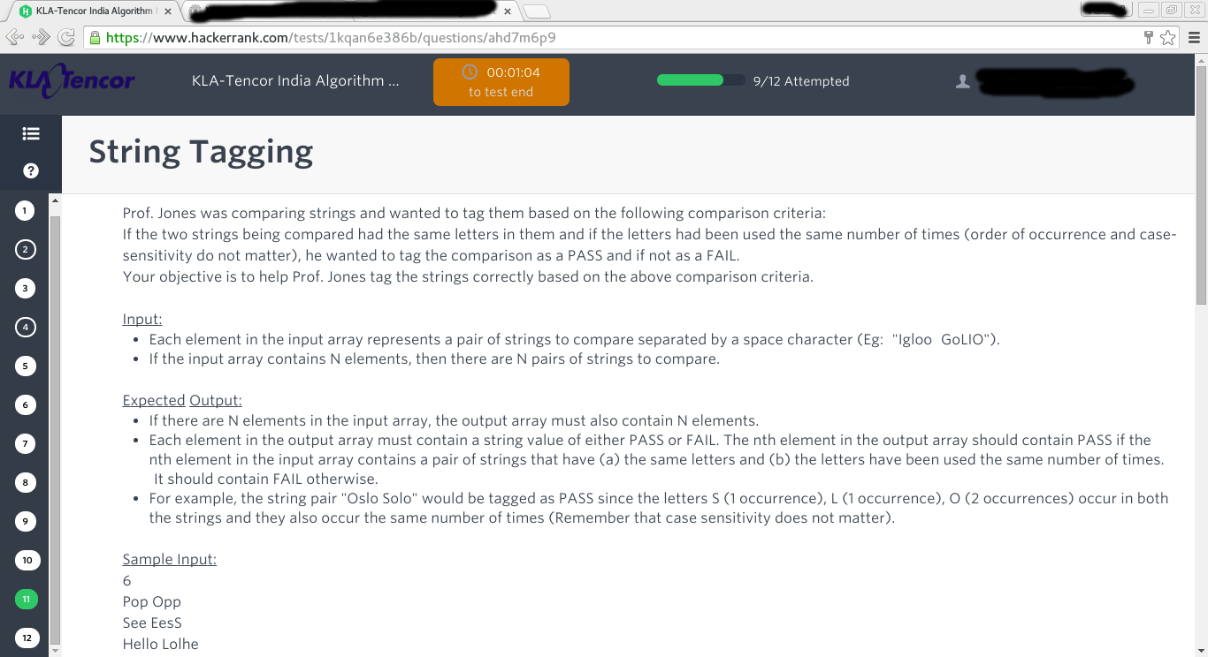

**10 Apti Questions(not tough)**

1. **A car travels at a speed of 64mph and its fuel consumption is 28 mpg. It has a 11 gallon tank which was full when it started but at that very moment began to leak fuel. After 112 miles the car stops with a completely empty tank. How many gallons per hour was it losing?**

**IITD...KLA Tencor**

**Application Deve Engi**

1. **15 Apti question in 60 minutes**

**Algo profile :**

1. **4 Programing questions**
2. **10 Apti questions**

**#same as IIT Bombay paper @IITD**

*KNOWLARITY @ IIT(MADRAS)*

*C/C++ questions:*

Date- 03/10/2015, Time - 80 Mins

CTC PLZ

1) kth Smallest Element in BST

2) Reverse a list in groups of given

size. <http://www.geeksforgeeks.org/reverse-a-list-in-groups-of-given-size/>

3) Reverse a stack using recursion. http://www.geeksforgeeks.org/reverse-a-stack-using-recursion/

4) Circular right shift of a number. Given a number of size N bits, circular right shift by k bits.

5) Remove dirty characters. <http://www.geeksforgeeks.org/remove-characters-from-the-first-string-which-are-present-in-the-second-string/>

Qualcomm IITK 08-10-2015\*/

All parts are MCQ

Important -

1. There was negative marking in all the sections(+1,-0.25).
2. Time for each section. If you do not complete a section in the given time, you will be automatically directed to the next section.

Aptitude - 20 minutes- (river boat (1), percentage, fraction,two Data Interpretation(6), probability and others (remaining)) - total 20

C - ( get the recursion value, functions calls, read about enums,function overloading,qu abt const keyword, MACROS, etc,;struct and union, which algo uses what subroutines (like Dijkstra uses queue); min no of nodes in an AVL tree of height 3 (solution?); const,mutable,auto keyword)

Find the output questions in C based on - extern, extern with static and register declaration, enum, union, right shift operator(>>),operator precedence, one question on #undef and one more question on #if as well.

electronics - timer 555, shift register, 8051, effect of doping on fermi level (impurity was boron); feedback circuit in op amps; number system, Getting state equations for 2 D flip flops from a 4 state FSM with 1 input and 1 output, 1 simple que on SR flip flop, a complicated TTL logic circuit was given and we were asked which gate it represents, 1 que on reducing a logic to sum of products, 1 rectifier circuit (asked the correct waveform of output)

(mentioned the topics; don’t remember the exact questions- read till certain depth)

(overall was rather tough given the very limited time, most people attempted only about half of the questions. same story for CS)

Computer Science(20 MCQ - 30 minutes time) - C-SCAN disk scheduling algo, Banker’s algo, binary search, recurrence relation of bogosort with given partition, no of page faults in LRU with frame size 6, no of swaps in merge sort, fork, this pointer, inorder traversal of a complete binary tree, strict binary tree.

Citrix @ IIT(BHU)

Date- 10-09-2015

50 MCQs including basic aptitude questions, c2hr time

++, networking, os, time complexity.

2 coding questions:

Q1. Its Prom Night tonight.There would be M boys and N girls at the prom tonight. Each boy wants a girl who is strictly shorter than him. A girl can dance with only one boy and vice-versa. Given the heights of all the boys girls tell whether it is possible for all boys to get a girl.

Input:

The first line contains M and N.

The second line contains M integers and each denoting the height of boy.

The third contains N integers each denoting the height of girl.

Output:

output all the pairs possible in increasing order of height of boys and print YES if all boys get a girl.

Q2. given two strings check whether first is a permutation of second string or not.

Bidgely @ IIT Delhi

6 aptitude question(moderate) - 15 min

2 coding :

1)(Very easy): Count the number of times f(0) and the number of times f(1) is called when we recursively compute fibonacci(n).

2)(Moderate) Given N numbers ,you are allowed to either pair a number with another number or leave it alone. you have to Maximize sum(output).

sum is formed by adding all unpaired numbers and adding product of each pair. Ex: n1 ,n2,n3,n4 . If you choose to pair n1,n2 & leave alone n3,n4

then sum =n1\*n2 +n3+n4;

Samsung Research Bangalore @IITB

Single coding question: Given n\*n matrix (n<=100), where some cells will have mirrors of one of two types. Type 1 : “/” and Type 2 : “\”. These mirrors will reflect light by 90 degree. A single ray of light enters at (0,0). You have to find out the count of the number of reflections on mirrors before the ray leaves the grid.**(minimum?)**

Solution: store current direction (4 directions possible). If current cell has mirror, update direction correspondingly and increase reflection count. Also keep updating x, y coordinates given direction. When current coordinates reach out of grid print the count.

**IIT-BHU SRI-B QUESTIONS :P**

**Q1) Here you've to find number of H,L,T,U in a NxN grid (contains only 0 and 1)**

**Each pattern can be represented in form of 3x3 matrix and can be rotated in 90,180,270 degrees**

**H - 1 0 1 1 1 1**

**1 1 1 0 1 0**

**1 0 1 1 1 1**

**L - 1 0 0**

**1 0 0 and three more forms**

**1 1 1**

**T - 1 1 1**

**0 1 0 and three more forms**

**0 1 0**

**U - 1 0 1**

**1 0 1 and three more forms**

**0 1 0**

**sample test case**

**0 0 1 1 1 0 1 0 0**

**0 0 0 0 1 0 1 1 1**

**0 0 0 0 1 0 1 0 0**

**0 0 0 0 0 0 0 0 0**

**1 1 1 0 0 0 1 1 0**

**0 1 0 0 0 0 0 0 1**

**1 1 1 0 0 0 1 1 0**

**output -> 1 1 1 1**

**It is guaranteed that a valid pattern exists and two patterns are separated by boundary of one.**

**Q2) Given height of N\*N buildings in form of NXN matrix and a ball can be assumed to be dropped from a building. ball will fall on its neighbour having lowest height.**

**e.g. ball from a[i][j] will fall on min(a[i+1][j], a[i-1][j], a[i][j+1], a[i][j-1]) and goes on falling. you have to find length of maximum path that can be traversed by ball.**

**input**

**3x3**

**1 2 3**

**4 8 9**

**6 0 5**

**output -> 4 (9->3->2->1)**

ADOBE @ IIT GUWAHATI 15-10-2015.

There were three coding questions(3 questions in 60 mins) :

https://www.hackerrank.com/challenges/sansa-and-xor

<https://www.hackerrank.com/challenges/sansa-and-xor>

<https://www.hackerrank.com/challenges/flowers>

[https:/](https://www.hackerrank.com/challenges/two-strings)

[/www.hackerrank.com/challenges/two-strings](https://www.hackerrank.com/challenges/two-strings)

.We had a discussion with the company guy after the test and they said, we have set easy question this time to check whether people will be able to do those or not. (actually in some NIT they gave hard questions and nobody was able to complete). So questions will be hard/moderate next time but 90% from hackerrank

Adobe @ IIT BHU 11-10-2015

Platform : Hackerrank, 90 mins

1. Given two Strings S and P, where P contains 'a'-'z' letters in some order and |P|=26. Find the smallest lexicographic permutation of ,S according to the order of alphabets in P.

// Can you elaborate more this problem??

// this is the same as sorting S according to the order defined in P, right?

// or am I missing something

YES IT IS SAME.

2. <https://www.hackerrank.com/challenges/clique>

// can you provide limits for this question? I mean was Brute solution acceptable?

// if not, how to solve this problem

3. There are N students, each having a list of favourite subjects. You have to find total no. of pairs of students that can help each other. Two students can help each other if they have a common subject.

Input Format:

First line contains the no. of students, N.

Next N lines each- has a number of the favourite subjects followed by the list of subjects.

Ex.

3

3 dfs bfs graph

1 flow

2 flow graph

Output:

2

N, Total no. of subjects (K) <=1000

Brute Force was not acceptable

Used Map to give each subject an index and then a boolean matrix of size N X K.

To find answer pick every pair of

student and then check whether this pair has a common subject, O(N^2 \* K) got accepted. //What is the use of Map?

**Picking up a pair and comparing their common subjects will take O(K), right? There are such N^2 pairs then how come your solution is O(N^2\*K) ?**

?ain’t this above solution brute force?

Had a boolean matrix of size N X K, say ‘arr’ where arr[i][j]=1 denotes that ith student has jth subject as its favourite. Now for every pair of student say s1 and s2, iterate over column and see if arr[s1][x]==1 && arr[s2][x]==1 for any 1<=x<=K.

If this happens then count s1 and s2 a pair. Hence O(N^2\*K)

I don’t know what you imply with brute force but some of us were having a Time Limit Exceeded, but above solution got accepted.

Or one could have after computing the array, compute for each column, the number of bits set and then compute NC2

(What was the time of this test??)

No, computing NC2 for each column may lead to repetition of pairs(One pair can have more than one common subject).

Adobe @ IITD

3 Coding Questions :

1., from where either one can get a candy, or give back a candy or do nothing. Calculate the maximum number of candy it can have at any time while going to destination.  
Input - X Y Z

ex - 3 8 3

ans = 6

4 2 7

ans = 6  
 Explanation - It can take 2 candies from 2 shops and then give back 4 of them to reach destination with Y; Do nothing at one of the shops.

// Easy questions just two maths equation

//solution?

//can someone suggest the soln????

Count(1) - Count(-1) = Y-X

Count(1) + Count(-1) + Count(0) = Z.

Iterate on Count(0), solve for the other two and keep track of max(Count(1)).

2. Not Exactly remember the problem statement, but was a Maximum Subarray problem.  
Easy one.

3. Given a string S1, and a String S2. S2 has character \* in it, in place of star we can put any other character also null. Calculate the number of substrings of S1 that can generate from S2.  
Input - S1

S2

ex - aabbaab

a\*b

ans = 8

Solution : // *Just split the string S2 with \* then lets say it result in S2’ and S2’’, find the occurrences of S2’ in S1 and store in Vector V1 and S2’’ in S1 and store in Vector V2 .  
for a indexes in V1 go to all index of V2 and check if index(V1)+len(S2’) < index(V2)*

*Microsoft @ IITB***Friday, 30.10.2015**

**platform: Cocubes**

***30min Apti***

***1 Hr coding***

**Aptitude:15 Questions (there were sets for each student)**

**Few questions I remember:**

**1)** The number of leaf nodes in a rooted tree of n nodes, with each node having 0 or 3 children is:

ans: (2n+1)/3 (Geeksquiz question)

**2) Fetch\_And\_Add(X,i) is an atomic Read-Modify-Write instruction that reads the value of memory location X, increments it by the value i, and returns the old value of X. It is used in the pseudocode shown below to implement a busy-wait lock. L is an unsigned integer shared variable initialized to 0. The value of 0 corresponds to lock being available, while any non-zero value corresponds to the lock being not available.**

AcquireLock(L){  
 while (Fetch\_And\_Add(L,1))  
 L = 1;  
 }  
 ReleaseLock(L){  
 L = 0;  
 }

Ans:fails as L can take on a non-zero value when the lock is actually available

(GeeksQuiz)

**3)** How many path are there to reach from A to B

A is bottom left B is at Top right.

Dark rectangle indicates there is **bridge**. //what to infer from bridge, can someone explain

**B**

|  |  |  |  |
| --- | --- | --- | --- |
|  |  |  |  |
|  |  |  |  |
|  |  |  |  |
|  |  |  |  |
|  |  |  |  |
|  |  |  |  |

**A**

options: a) 165 b)170 c) 195 d) 209

**Ans??-- did someone get the ans for this?**

(How??) wasn’t there a condition like steps should be minimum? Otherwise it can go to infinity (going into a loop) or at least a condition like we can go only once on any block.

**4) & 5)** Two Questions on linked list: What is the output (Not remembering exact Questions)

List was given 1-2-3-4-5-6-7-8; Some operation on list and list was printed at last.

**6)**  Question on Virtual Function: (What is output)

3 classes were given each overriding same function of base class.

Array oGiven an array of length n. Divide the array between two subarrays such that diff between sum of each subarray should be minimumf base class storing objects of 3 classes. Then a call to functions made.

**7)** Question on Java Char Array, character stream. (What is output)

**8)** What is output of this C++ code: ( not remembering exact code)

Conversion Operator overloading:

**9)** Question on C preprocessing 9 (Not remembering exactly)

But was somewhat like this:

#define ap(m,n) m##n

#define s(x) #x

int main(){

int m=14,n=4;

do{

printf(“%d”,ap(m-,++n));

}while(s(90),4)

}

Options:a) 11, b) compile error , c).. , d)..

doubt: what will while(s(90),4) do. I think s(90)=”90” right??

**10) & 11)** Questions on Structure pointers

**12)** **Consider a weighted complete graph G on the vertex set {v1, v2, ..vn} such that the weight of the edge (vi, vj) is 2|i-j|. The weight of a minimum spanning tree of G is:**

(A) n - 1 (B) 2n- 2 (C) nC2 (D) 2 **(GATE CS 2006)**

ans: 2n-247/--------------------

13) Consider the following array of elements. 〈89, 19, 50, 17, 12, 15, 2, 5, 7, 11, 6, 9, 100〉. The minimum number of interchanges needed to convert it into a max-heap is:

a) 3 b) 4 c) 5 d) 2

ans: 3

14) 15) Not remembering

***PART 2) Coding: Two coding questions:***

**Platform: cocubes**

**1) Longest Even Length Substring**

Given a string of digits. Find the length of longest even length substring such that the sum of left part = sum of right part. Return 0 if no such substring exists.e.g. given string 1523457

The longest even length substring will be 5234

so output= 4

**2) Minimum difference of subarray**

. for even n: subarray lengths should b n/2 exact

for odd n: subarray lengths should be (n-1)/2 and (n+1)/2

e.g. given array 5,6,11,13,14,25 two subarrays: {5,6,25} and {11,13,14}

diff between sums = 2 **so output 2.**

**solution please?**

**// DID BRUTE FORCE WORK FOR THIS ONE, i.e. creating all possible subsets of size n / 2**

**// Also, how many testcases (for both) ?**

**PFA Screenshots**

**12194291_1041603735892153_449869955_o (1).jpg**

**12193037_1041603732558820_1678409439_o.jpg**

*Coupondunia @ IIT(BHU).*

3 questions 90 minutes

CTC Plz = **16.5 LPA**

1. Santa candy

Given n children. Santa wants to give candy to all children such that all children get distinct number of candy. Also ith child can hold only max[i] candy. Find number of ways santa can distribute candy. mod=1000000007

sol: First sort! Then for( i=0:n) { ans=(ans\*(max[i]-i))%mod;}

initial: ans=1

first children can get candy in max[0] ways, 2nd in (max[1]-1), 3rd in max[2]-2 ways and so on.

**Could you please explain this. Also what is val of ans initially**

2. A set of students x1,x2,x3,.....xn<10^9. Find the set x1,x2,x3,.....xr which have maximum score d. A score d is maximum if (x1&x2&....&xr) modulo 2^d is zero. Return the set of students which have max value of d.

(is that set continues?)

Citi @ IIT Roorkee

24-10-2015 (125 min)

Three sections with multiple choice questions -Also, it’s mentioned that the test is *adaptive*

Quantitative aptitude - 16 questions 16 min

Logical Reasoning - 14 questions 16 min.

CS - 25 questions (Mostly DS/ C Output) 35 min

Coding - 2 questions. 60 min.(different set for everyone)

(the questions were different for diff. individuals)

1. Find minimum sum path from root to leaf.
2. find matrix multiplication with its transpose .. // Please elaborate

You are given a value k and dimensions m x n. The first term of the matrix is k then it is k+1...so on (row by row) until the matrix fills. Now multiply this matrix with its transpose and return the resultant matrix

1. find if a given binary tree is sub tree of another given binary tree.
2. Reverse the latter half part of a given linked list.
3. Print numbers in a given fashion.

given n=4

1\*2\*3\*4

9\*10\*11\*12

13\*14\*15\*16

5\*6\*7\*8

given n=5

1\*2\*3\*4\*5

11\*12\*13\*14\*15

21\*22\*23\*24\*25

16\*....................\*20

6\*7\*8\*9\*10

(I HAVE MODIFIED THE PATTERN).. yes it is correct .

1. find gcd of given n numbers
2. the grid, we should check whether the rat can travel to cheese(in other words 9) following only ‘1’s.Given a mxn grid consisting of 0 and 1 where 0 denotes wall and 1 denotes the movable path. Grid also consists of number 9 at one coordinate which denotes location of cheese. A rat starts at position (0,0) in
3. Given array={ 1,1, 3, 3, 3,2, 5,5,5,5, 5, 9, 9}, we should arrange them in the decreasing order of frequency and the elements with same frequency should come in the order same as in the given array. So the expected output array is {5,5,5,5,5, 3,3,3,1,1,9,9,2}

// Do u guys remember what all topics were covered in mcq.??

Citi @ IIT Delhi

25-10-2015 (125 min)

Same as IITR. // Do u guys remember what all topics were covered in mcq.??

Citi @ IIT BHU 27-10-2015 (125 min)

Same as IITR.

Citi @ IIT Bombay

31-10-2015 (125 min)

Same as IITR.

Citi @ IITM 29-10-2015 ( 125min )

same questions as IITR.

**Flipkart @IIT Delhi 29th October**

**2 programming questions on hackerrank - 90 mins**

Q1. Progress tracker - You have to transfer your files from external hard drive to desktop. The time taken for the transfer is represented as HH:MM:SS. A percentage depicting the transfer completed is displayed for whole values of seconds. 0 and 100% are not included. How many times will the percentage be displayed.

For eg. 00:10:00 - a percentage increase by 1% every 6 seconds. So, 99 ticks

00:14:00 - a percentage increase of 5% every 42 seconds. So, 19 ticks.

Q2. Wine glasses - You have to place n wine glasses in cardboard boxes. Each cardboard box has length l and width of glass is w. A unit distance has to be left between the glasses. Glasses are placed within a box if the number of the glasses in a box is not divisible by 13. What is the minimum number of boxes required.

For eg. n=8,w=2,l=5 so 4 cardboards

n=26,w=2,l=80 so 2 cardboards //// It should be 1 cardboard … 80/(2+1)=26+2 //// It won’t be 1 cardboard as divisible by 13 is not allowed.

**What will be output for: n = 73, w = 3, I = 60 // My Ans: 5 Boxes(15,15,15,14,14)**  Is it correct??

**Solution for this?**

**(to find errors in loop(mostly variables not initialized) , classes , encapsulation, stable sorting type,selection sort, functions , bubble sort , minimum number of stacks to make queue ) The mcq’s were very simple**

*Flipkart 3 Questions :*

<https://www.hackerrank.com/challenges/string-similarity>

**Expert level Question??**

**Solution????**

*Flipkart @ IITB*

Date: Nov 1,2015

Platform: hackerRank

*Same Questions as IITD.*

1. Progress Tracker
2. Wine glasses
3. String Similarity

FlipKart @IIT Hyderabad 21/Nov/2015

250 Min exam(3 section. one coding and 2 objective section)

1. Two coding question

# Maximum difference between two elements such that larger element appears after the smaller number

* + 1. <http://www.geeksforgeeks.org/maximum-difference-between-two-elements/>
  1. shortest palindrome
     1. [http://www.geeksforgeeks.org/dynamic-programming-set-28-minimum-insertions-to-form-a-palindrome](http://www.geeksforgeeks.org/dynamic-programming-set-28-minimum-insertions-to-form-a-palindrome/)/

1. 42 objectives (Technical)
   1. OS
      1. demand paging, deadlock avoid, critical section, child process creation time, what is shell?,
   2. DS and ALGO
      1. complexity of DFS (adj matrix representation)
      2. preorder to postorder(all variation, two question)
      3. complexity of B+ tree
      4. insertion sort
   3. DBMS
      1. lots of sql query output question
      2. Normalization
   4. C/C++
      1. virtual constructor
      2. operator overloading
   5. Network
      1. for a given subnet, what is ip address?
   6. grep command (see use of $,^ etc)

Hikari Tsushin @ IIT Roorkee

23-10-2015 (75 min)

Three section with multiple choice question -6+

Quantitative aptitude - 20 questions

Logical Reasoning - 25 questions

Coding - C output/Data Structures - 30 questions

Very easy paper.

CARWALE @ IIT GUWAHATI 13-10-2015

CTC: 17lpa

There were 4 problems and 2 hours of time. Platform was hackerrank. The problems were taken from codechef as it is so I’m posting the link of the original questions:

<https://www.codechef.com/problems/CSUMD> <https://www.codechef.com/problems/LINEPROB>

<https://www.codechef.com/problems/LWS>

<https://www.codechef.com/problems/EQUATIO>

*CISCO @ IITB*

Date:1-Nov-2015

platform:

50 MCQs in 60 minutes

Format: ATE questiApti + CS Gons + Electronics Questions on CMOS, memory organizations, capacitor voltages etc.

*can’t remember all the questions. Sorry :(*

*CISCO @ IITR*

Same as IITB

*MORGAN STANLEY @IITB*

*//CTC?* Gross=13.25

Date:31-10-2015

Platform: HackerRank

19 MCQs and 2 coding questions:

MCQs - apti and GATE

**Coding Questions:**

**1)CRAZY TRAVELLER**

**A traveller want to go from point 0 to N.**

**He can go from position i as walk(i+1), jump(i+2), long-jump(i+3).**

**Find out in how many ways he can go from point 0 to N.**

**Constraints: 0<N<10^7**

**Output should be modulo 10^9+7**

**INPUT:** T test cases. each test case has N.

4

1

2

3

5

**OUTPUT:** total ways for each test case

1

2

4

13

**2)CARDS ON A GRID**

**Given a grid of cells.There are alphanumeric{0-9,a-z, A-Z}cards stacked over cells of grid. Each card will be put at-most one time.They can span multiple cells. Some cells may not contain any card over them. Multiple cards can be stacked over each other.**

**Finally when you will see a top-view of grid you will different numbers, alphabets cards on grid. Find the original order of placement of cards on grid. In case of multiple orders give orders in ascending ascii value.**

**If no order is possible the output “ERROR!”(without quotes)**

**INPUT:** it will contain string array. Each string can contain alphanumeric character or a dot (.)- dot indicated absence of any card at that cell.

{“bAAb”,

“bAAb”,

“bAAb”,

“.AA.”}

**OUTPUT:**

bA

**Explanation:**

As you can see in card of ‘A’ is placed on column 2,3 of each row and card b is placed

from column to 1 & 4 on rows from 1 to 3.

Hence b must be placed before A. Hence the order “bA”.

**Visa @ IITD:**

**// Date??**

* 4 coding questions to be done in 1.5 hr

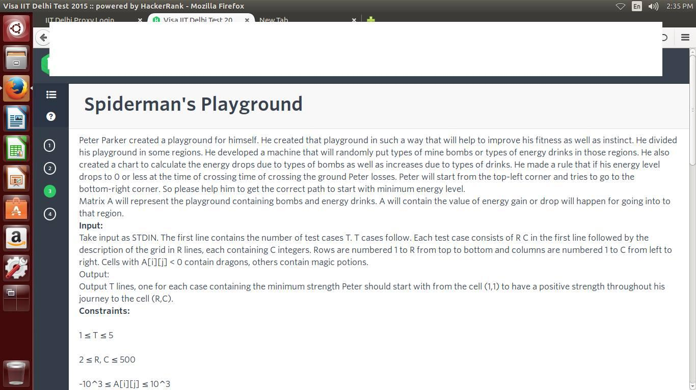 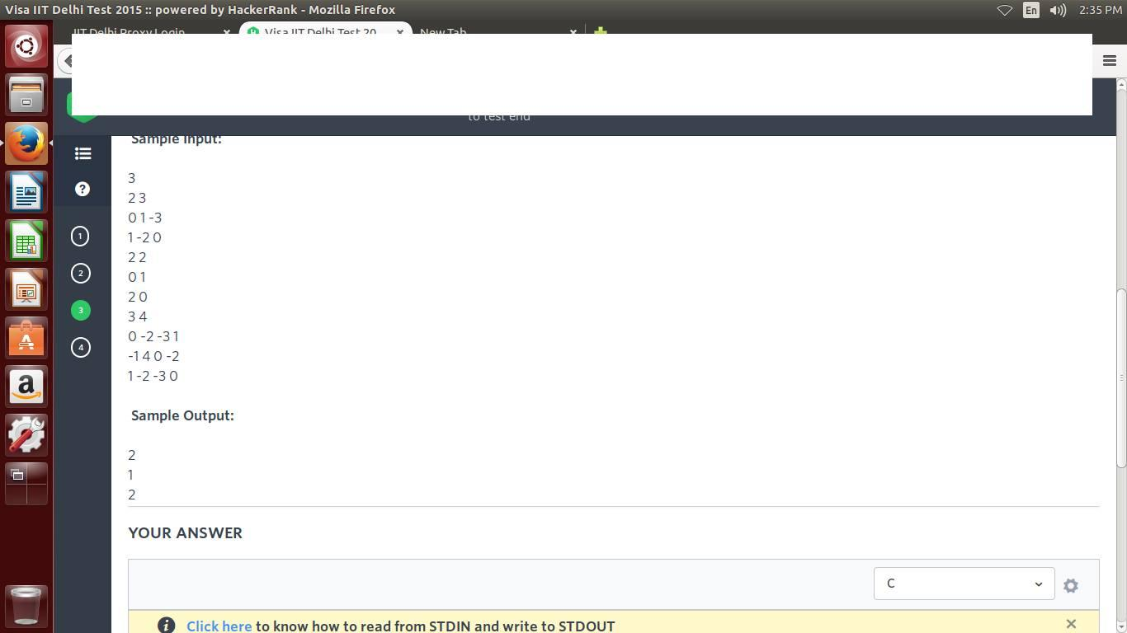 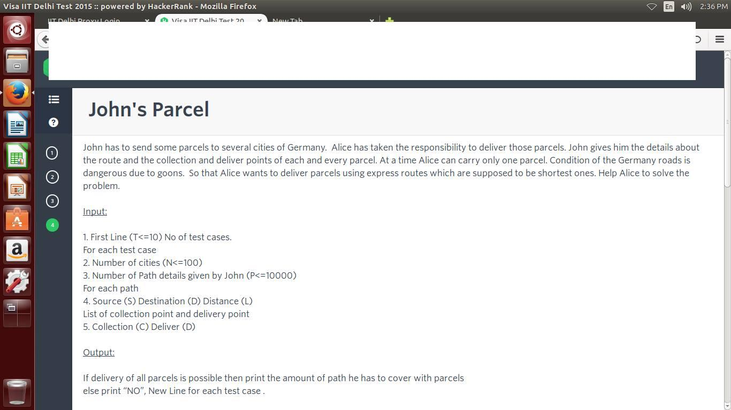

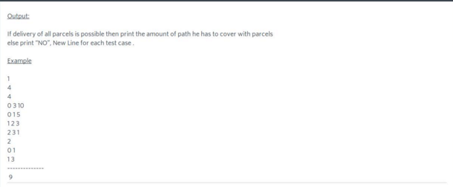

When do we consider that a parcel can’t be delivered ?

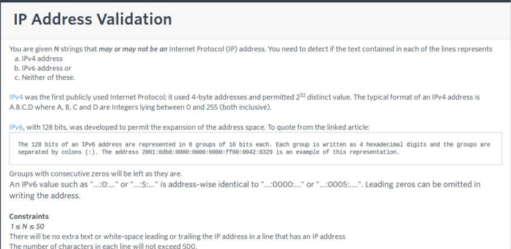

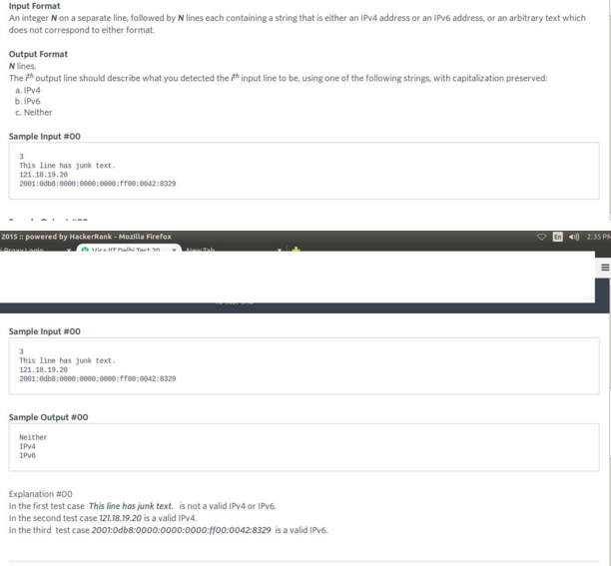

VISA@IITB (23/11)

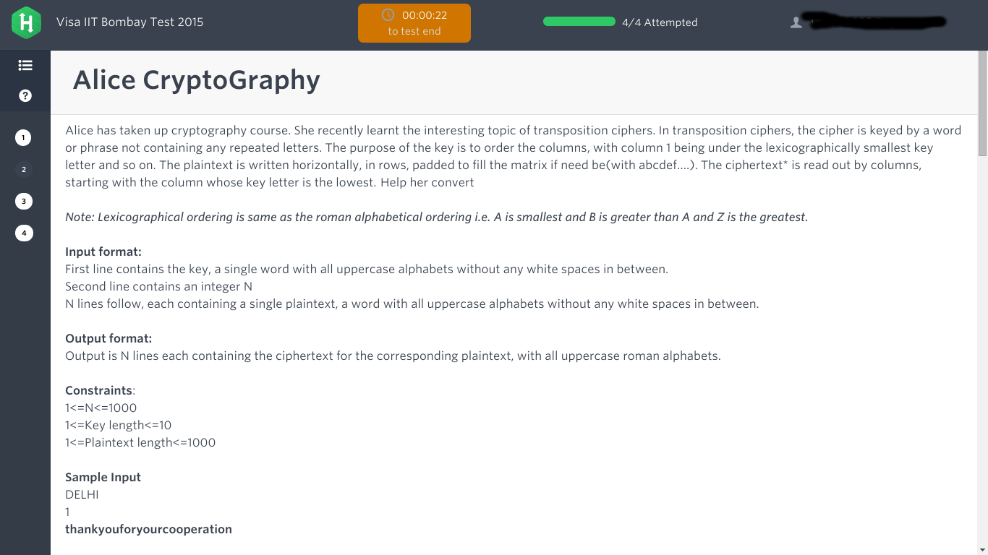4 coding questions on Hackerrank, 90 mins

1.A balloon can provide internet access to any number of cities. For every pair of balloon(say P and Q), there should be at least one city that P provides internet service to and Q does not. Find minimum number of cities given number of balloons

// Can somebody please explain this

2.Given a key and plaintext find the cipher text by using columnar transposition cipher

3. Generate all substrings of a string

4. Given some fractions (n1/d1, n2/d2, n3/d3 and so on), find their sum nSum/dSum. You have to output nSum and dSum after reducing the fraction to lowest terms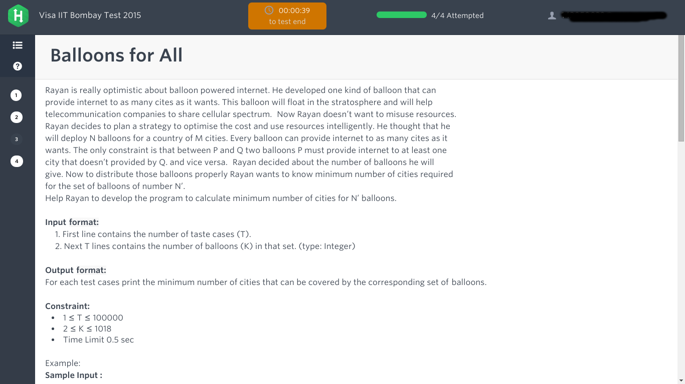

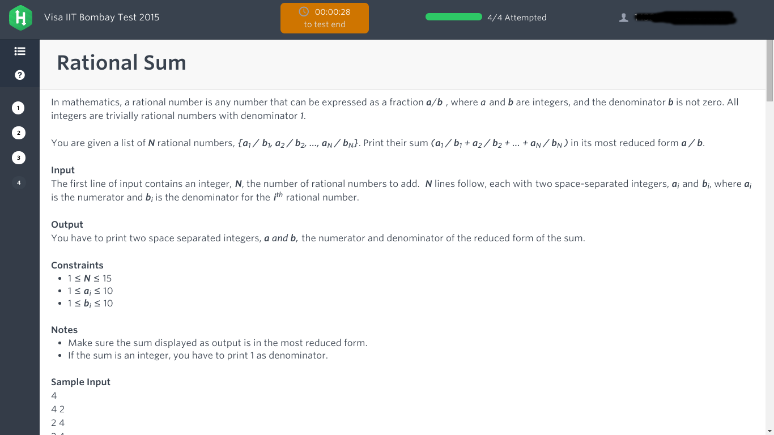

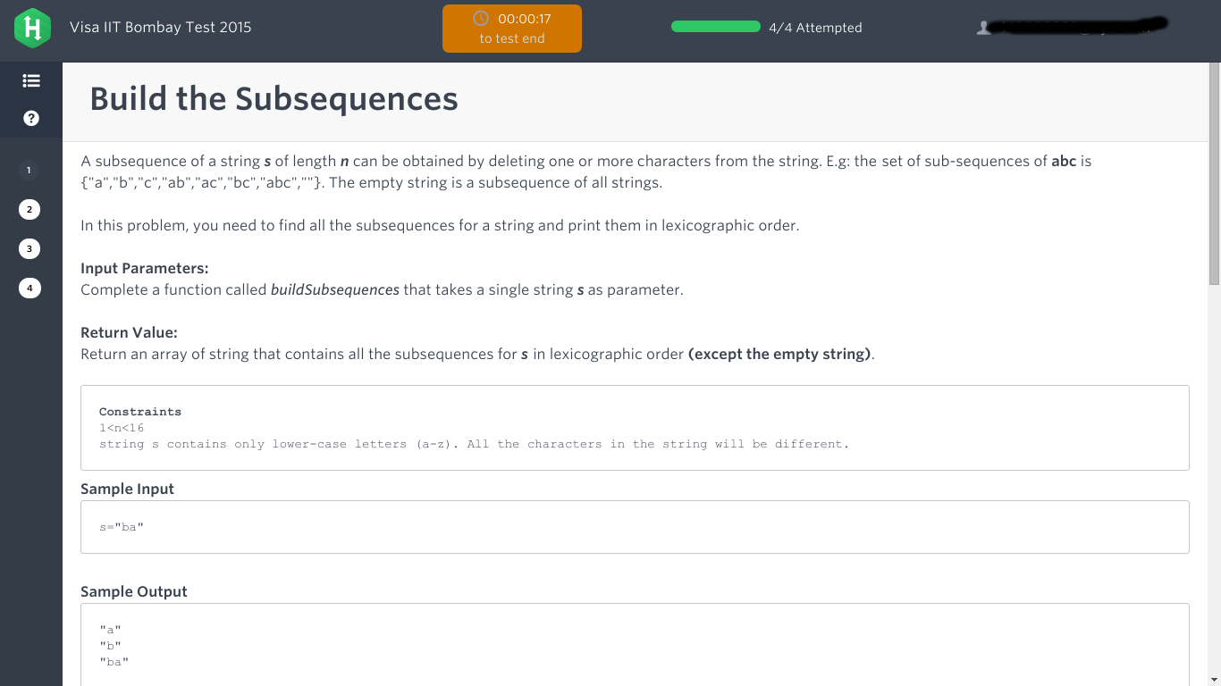

Target @ IITR

(23-11-2015) 60 min.

aptitude

30 questions mostly on c++ and some on (P&C)

1 coding questions

Q. Given two sets of strings, good set and bad set, where each string consists of only 0s and 1s, we make a third set taking XOR of every possible pair from first set and second set. We call this third set the evil set.  
Now in the code we have to implement a function whereby you are given a good set and an evil set and you have return the number of elements in the bad set.  
Number of strings in each set can be upto 50.  
Each set will only contain distinct elements.

EXL @ IITR

(23-11-2015) 45 min.

40 Questions   
10 verbal

10 logical reasoning

20 quantitative aptitude

SAPLABS @ IIT BOMBAY

24/11/2015 (sap labs)

6 parts(Two coding ques,20 analytical,20 design,20 apti, 1 essay, 10 Technical ) + 60 psychometric Question

Time: 1.35 hr + 10 mins

essay ??

CGPA??.

1) Given an expression a string “**A** op **B** = **C”.**

op = {+,-,\*,/}. Among A,B,C anything can be missing e.g. “1+X=3”

Then find the value of X.

2) *One question was similar to this:* Find Number of possible arrangement of letters in char array such that no two ‘x’ are together.Given string is of x’s and y’s only.

e.g. input = {‘y’,’x’,’x’,’y’,’y’}

output = 6 ← *[(3!\*4\*3)/(3!\*2\*)]*

*http://math.stackexchange.com/questions/483071/seating-arrangements-of-5-boys-and-4-girls-in-a-row-with-no-two-girls-adjacent*

3) Bleak Numbers: <http://yougeeks.blogspot.in/2015/10/sap-check-if-number-is-bleak-or.html>

4) Money Collector

5) Palindrome Or Not

6) Reverse words and capitalize first letter.. Input char\* Output should be returned as char\* only..

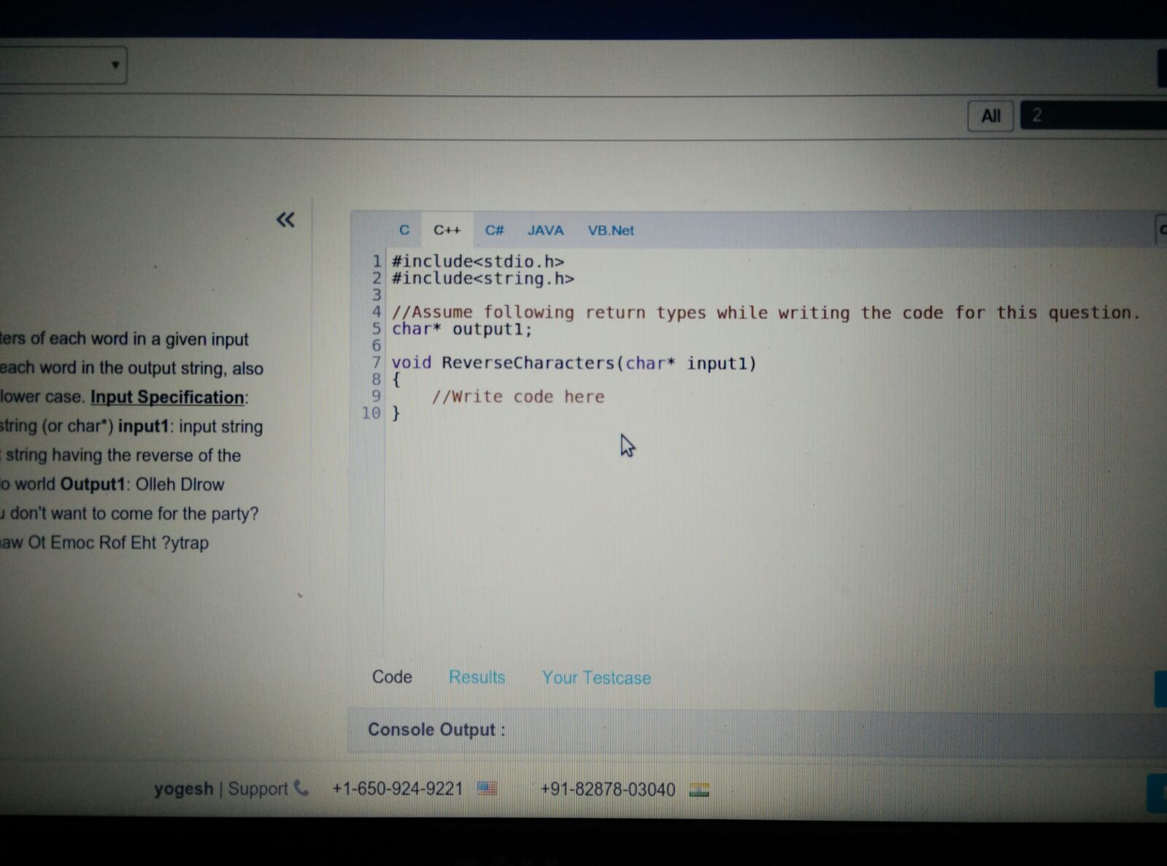

7) Given three numbers check if they are in AP or GP. Output the fourth number depending on the type of progression.

8) Number of arrangement on two sides of road. Building and space. No two building adjacent. Space can be. One section consist of pair of plots on either side of road.

Input. Number of sections.

9)Find the sum of digits of all number between range m to n ; m<n.

input. m and n

Ebay @ IITR

(25-11-2015) 90 min.

There were three sections in the test. Each sections had a time limit of 30 min.

1. Quantitative aptitude - Multiple Choice - Medium/Hard DI questions
2. C++/OS/DBMS - Multiple Choice
3. Coding - 3 questions out of which only two were supposed to be done. No checks were there you just had to write the code in a text box. Can be pseudo code too.

Q1 An sorted array has been rotated multiple times. You have been provided the final array. Now given a number, you have to tell it’s position the final array. ( O(logn) solution was expected ).

Q2 Longest increasing subsequence length

Q3 Write a function to check whether a tree is balanced or not. A tree is balanced if for no two leaves difference between root to leaf distance doesn’t exceed 1.

Platform was hirepro.in. All questions carried 1 mark each including coding (Ya it’s kind of f’d up). There was no negative marking.

GRABHOUSE @ IITD(25-11-2015 | 60 Minutes)

**15 Technical Questions** - Sorting, Database, Trees

**1 Coding Question** - Given a number D,A,B and an array Arr[N]. You can perform following operations on D, +A,-A,+B,-B any number of times. Output the count of number of terms in Arr[N] you can make using the above operations on D.  
Example- N=3,D=4,A=4,B=6  
Arr[N] = {8,12,15} Output 2

AMEX @ IITR (Management Trainee)

(26-11-2015) 45 min.

20 aptitude questions 45 min. very easy

**Headout @IITD 27/11/15**

2 Questions - Both Coding - Platform Hackerrank, 60 Mins

**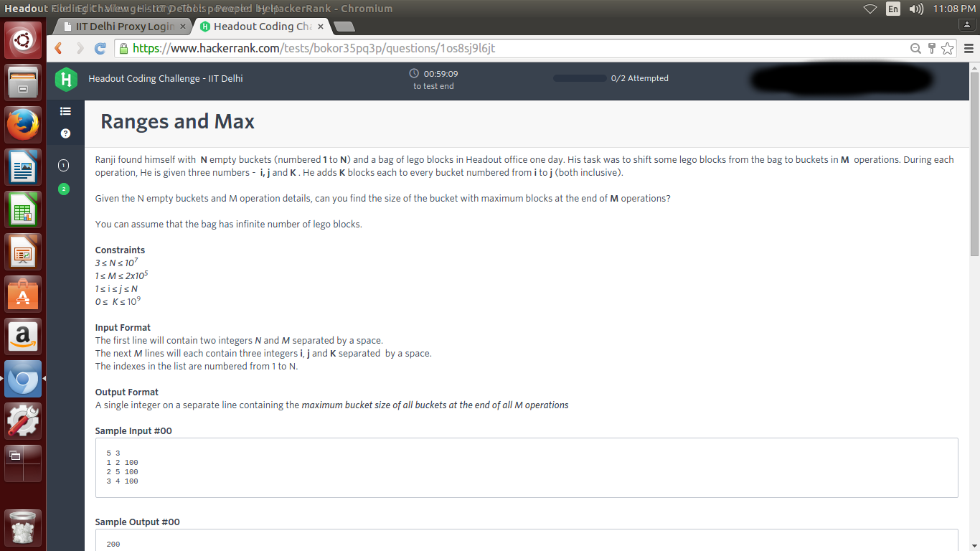**

**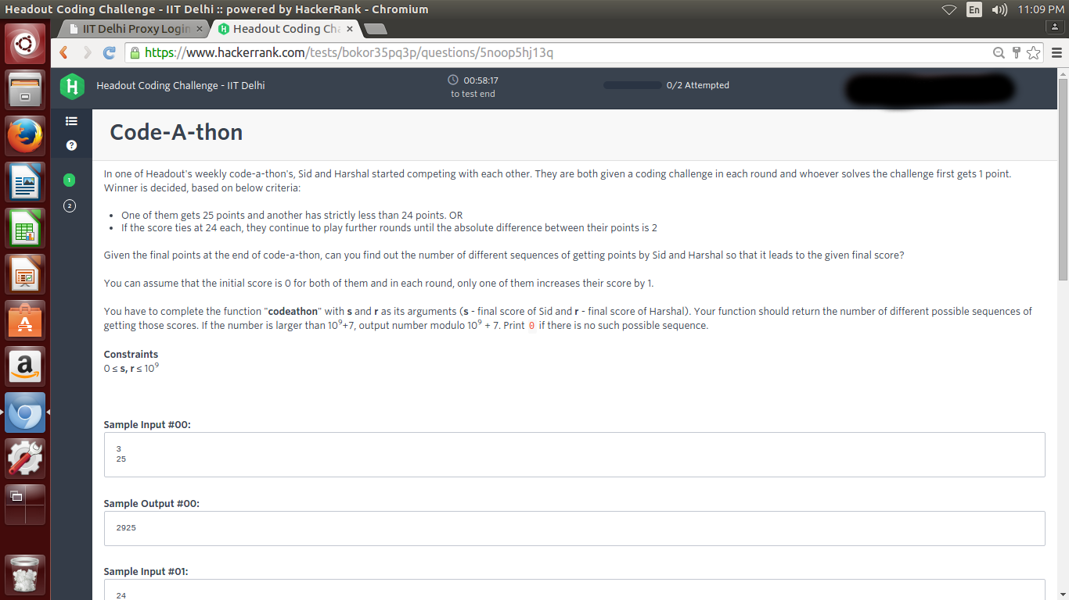**

**Roposo.com (Relevant E Solutions)@IITD 28/11/15**

7 Questions - 4 Coding, 3 MCQs - Platform Hackerrank, 60 Mins

CROWDFIREAPP @ IITB

(Software Engineer)

(25/11/2015) CTC = 30 L

2hr 4 ques platform hackerrank

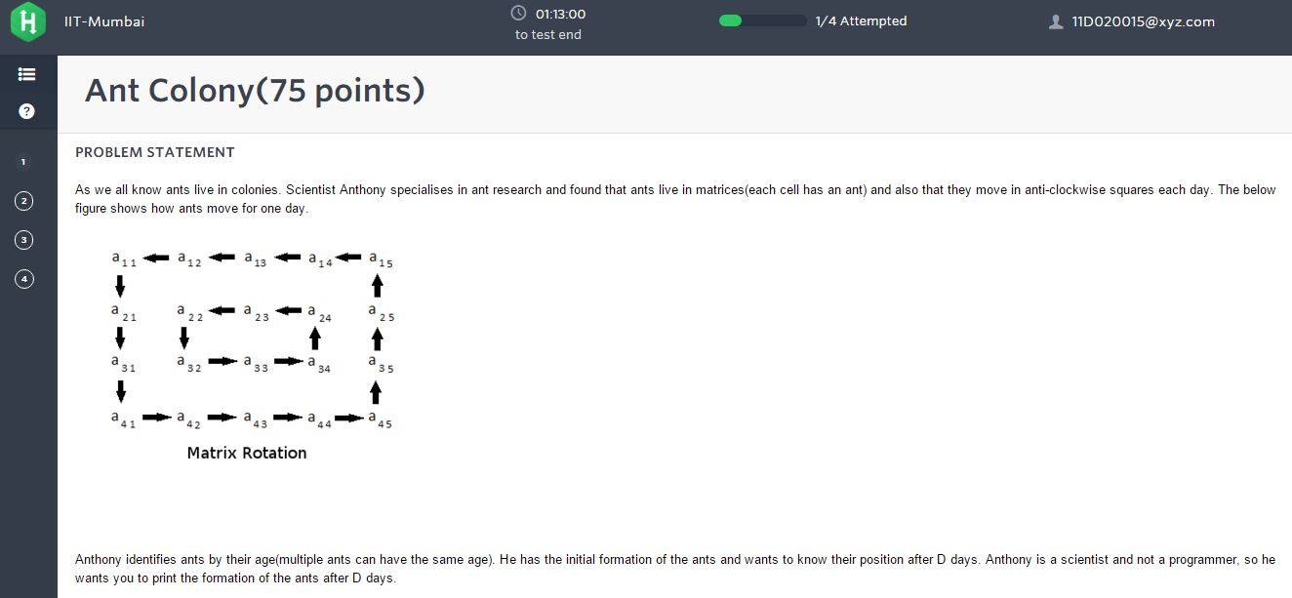

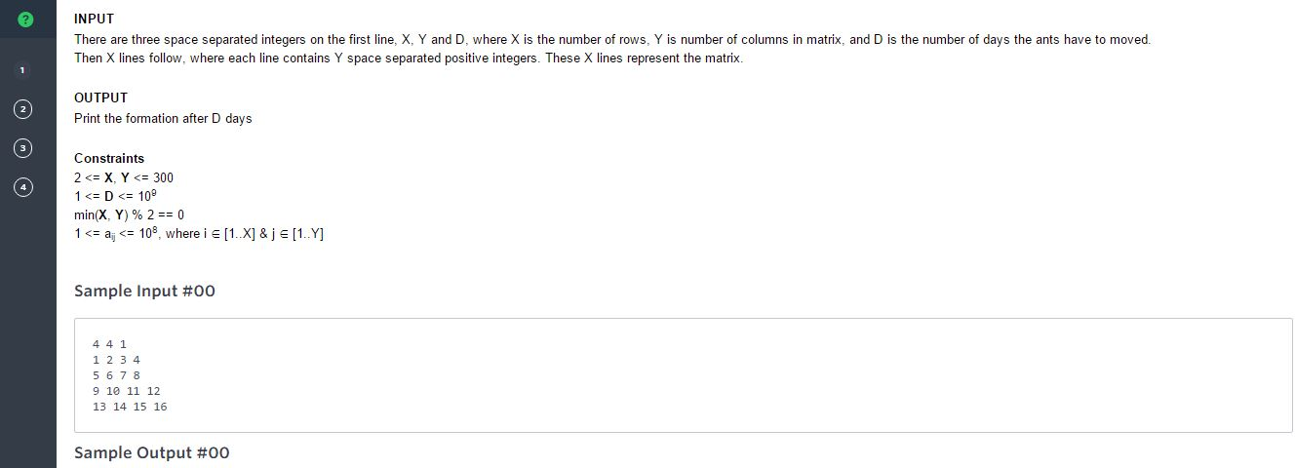

Ques 2:

Ques 3

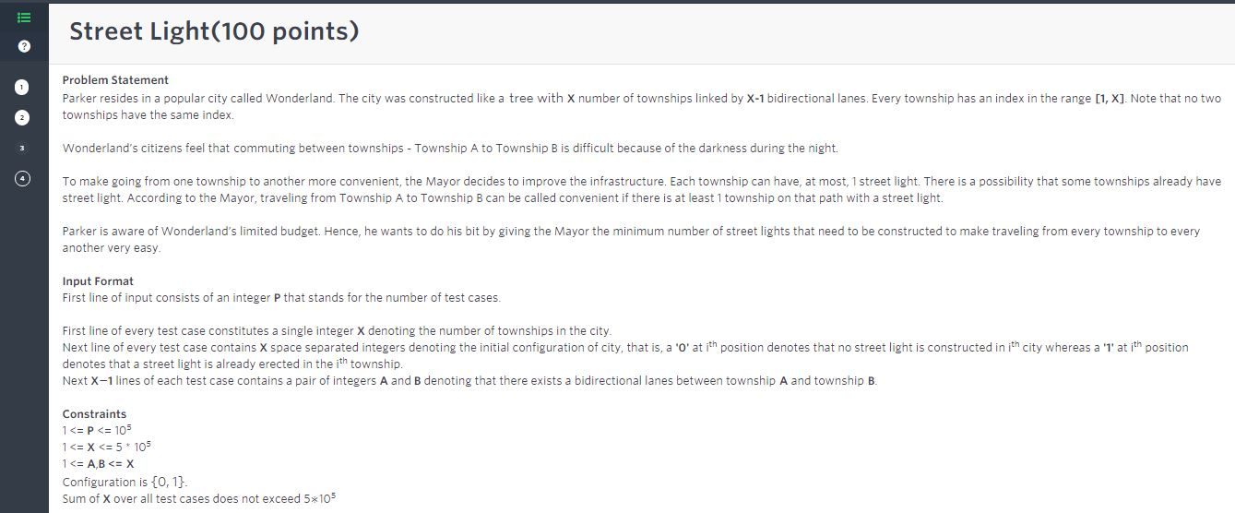

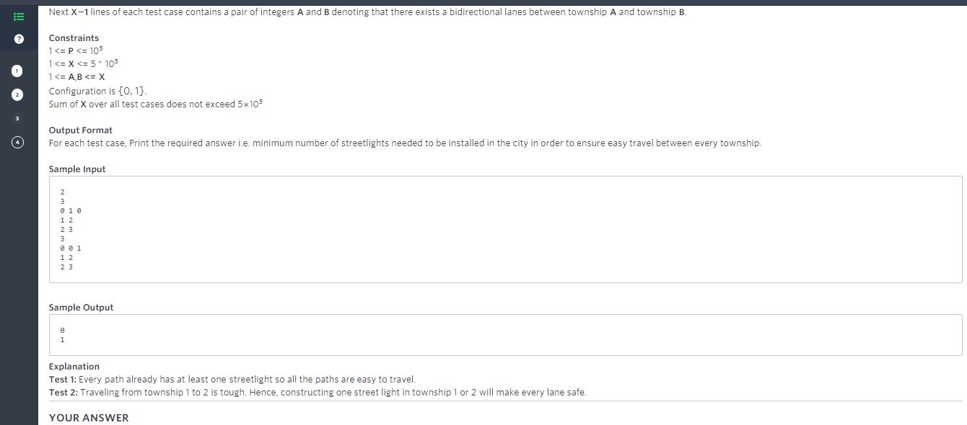

Ques 4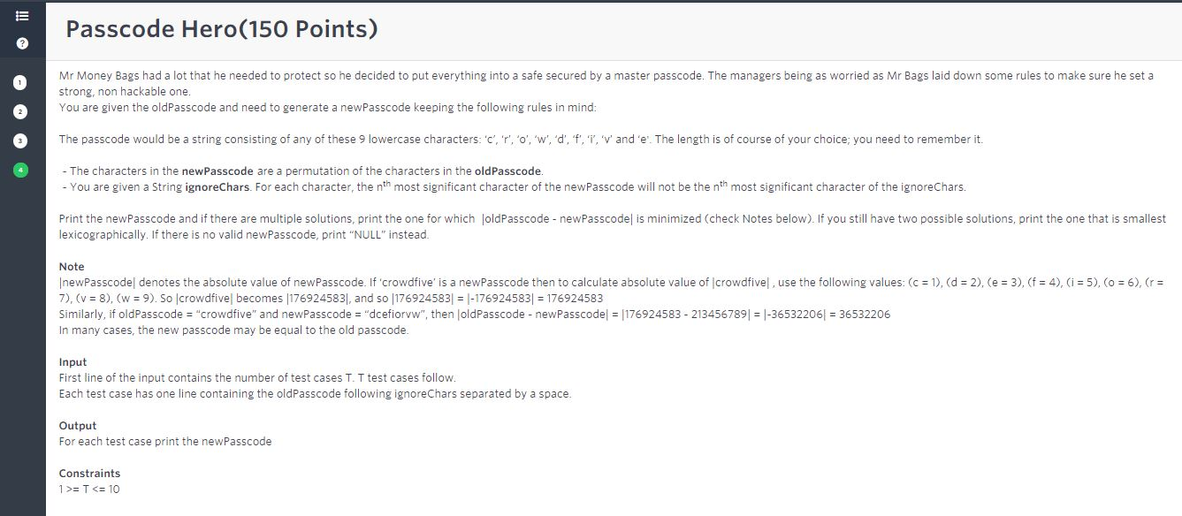

**INTEL @ IIT Bombay**

25 Aptitude and 25 CS/Electrical MCQ questions in 60 mins. (online)

1 written coding question 20 mins. (pen and paper)

Personally, both apti and tech MCQs were very tough. I got frustrated while doing it.

Written coding questions was to “Print the preorder sequence of a Balanced BST after removal of a node”. We need to write code for insertion, deletion, rotations, preOrder etc of BBST. All in 20 mins and on a blank sheet.

**INTEL @ IIT Delhi 28/11/15**25 Aptitude - (DI 3 data sets with approx 3 questions each) and 25 CS/Electrical MCQ questions in 60 mins. (online)

Platform - HirePro  
\*\* There were questions whose options were not matching even for the simplest of calculations. Prefer leaving them rather than marking something close.

1 written coding question 20 mins. (pen and paper)

“Print all the ancestors of a node starting from eldest. Given that left child > parent and right child < parent.”

**Saavn @ IIT Bombay**

**3 coding questions**

**Time - 1hr**

**1.**

**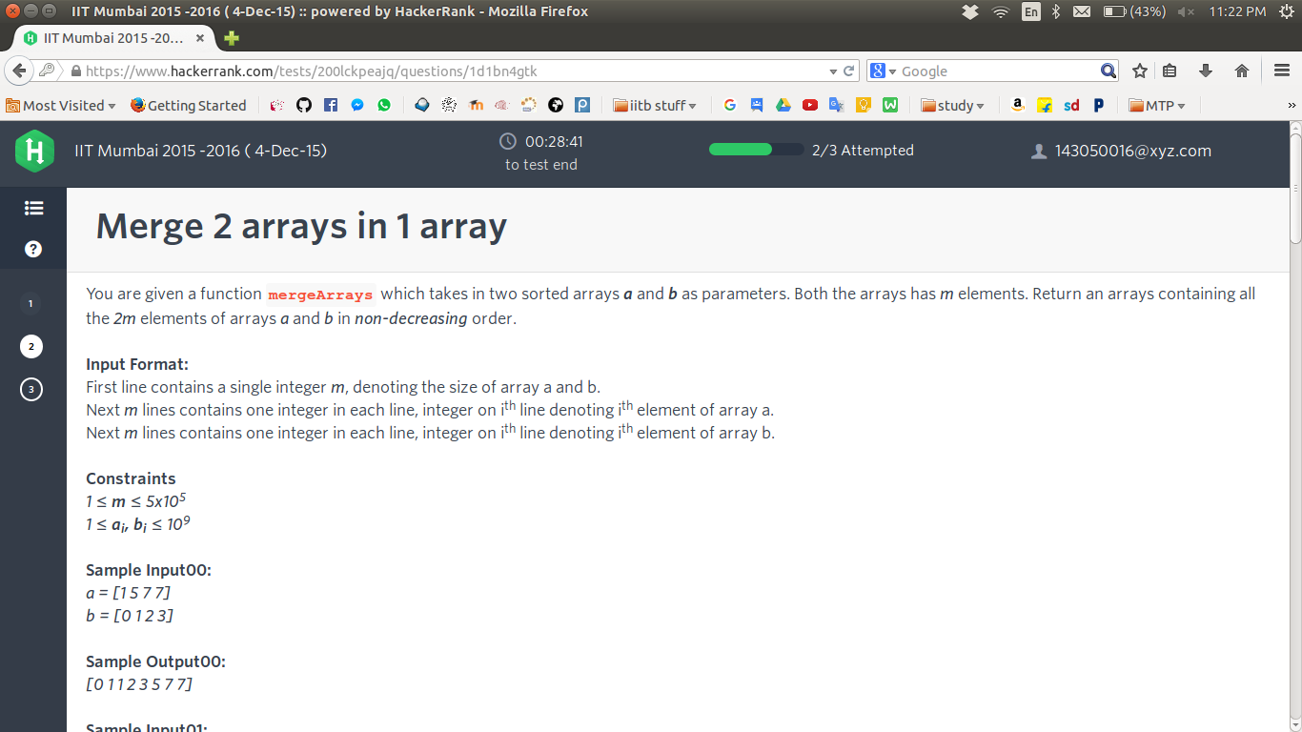**

**2.**

**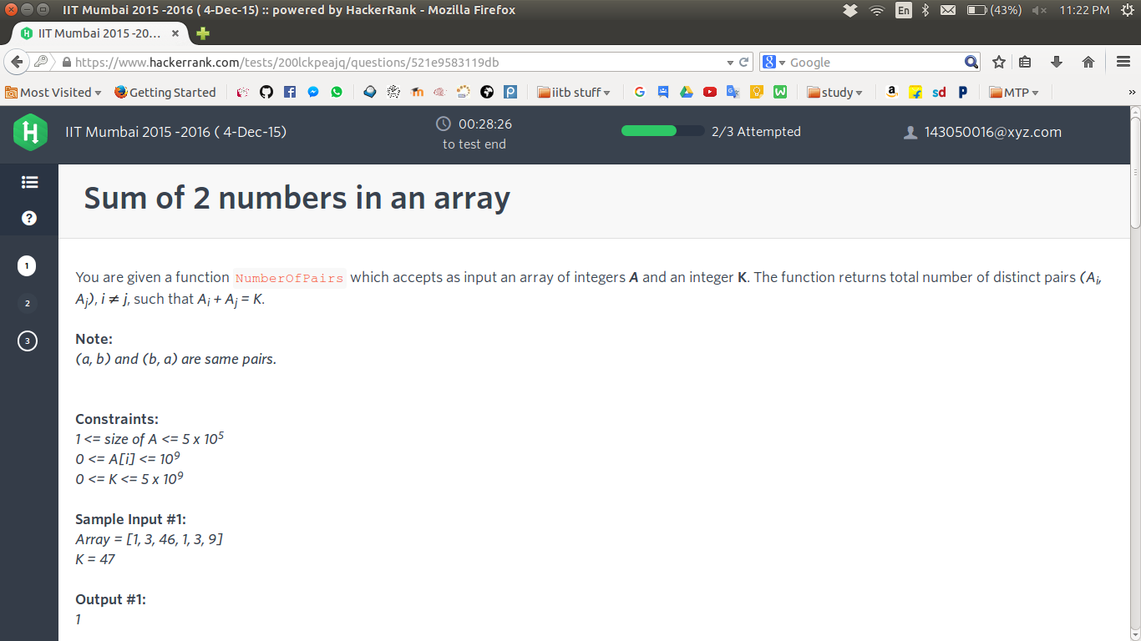**

**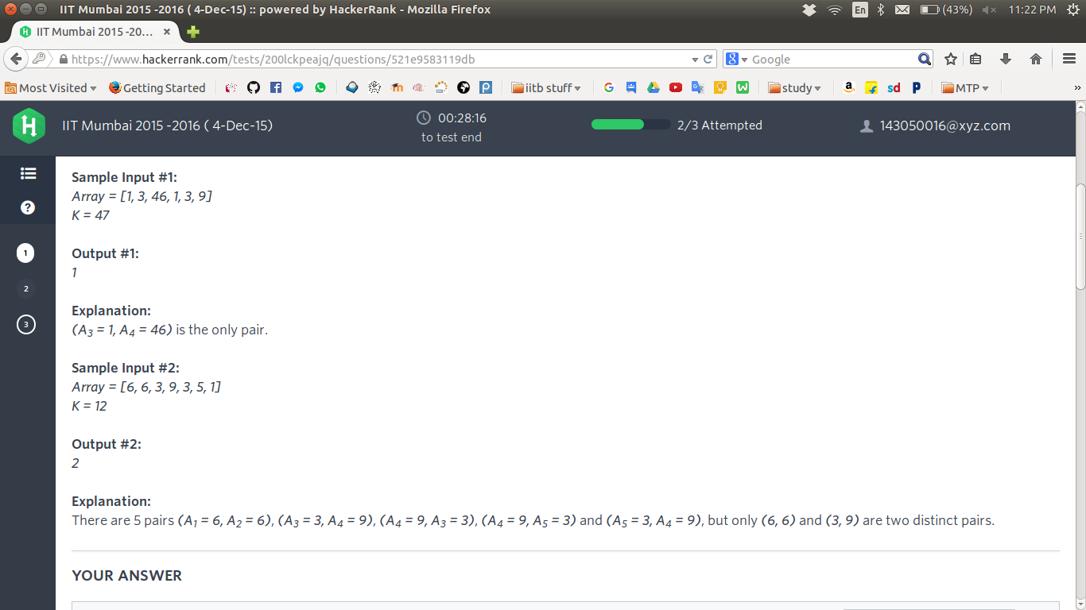**

**3.**

**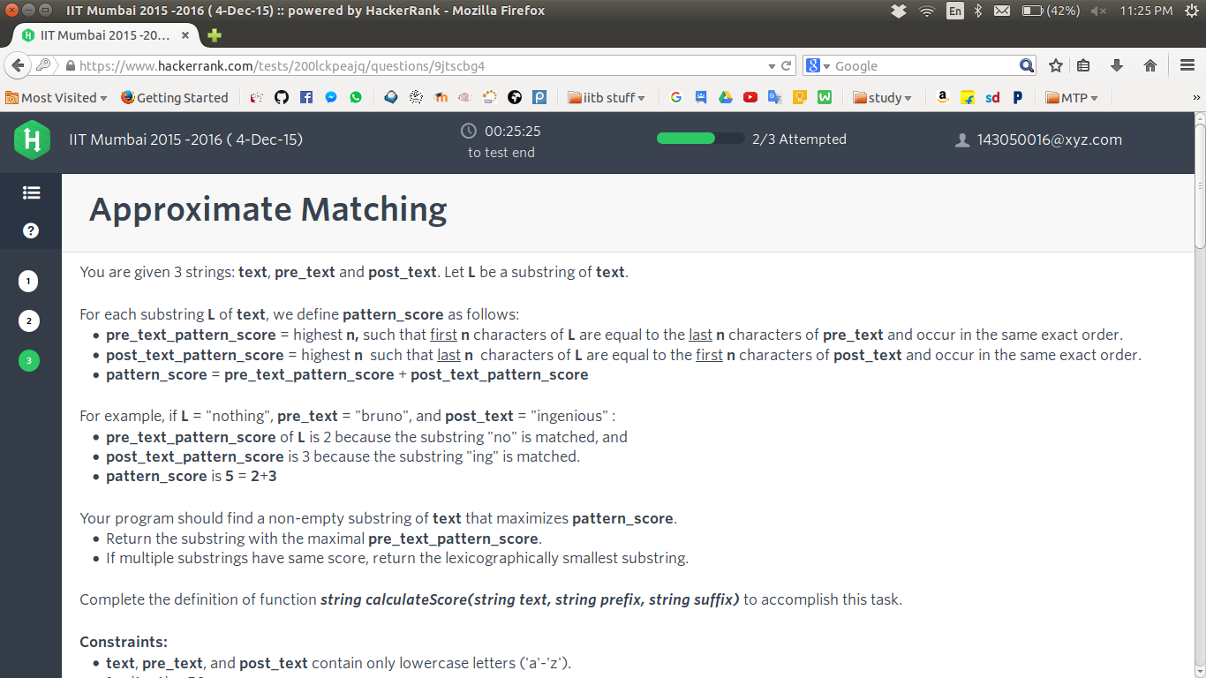**

**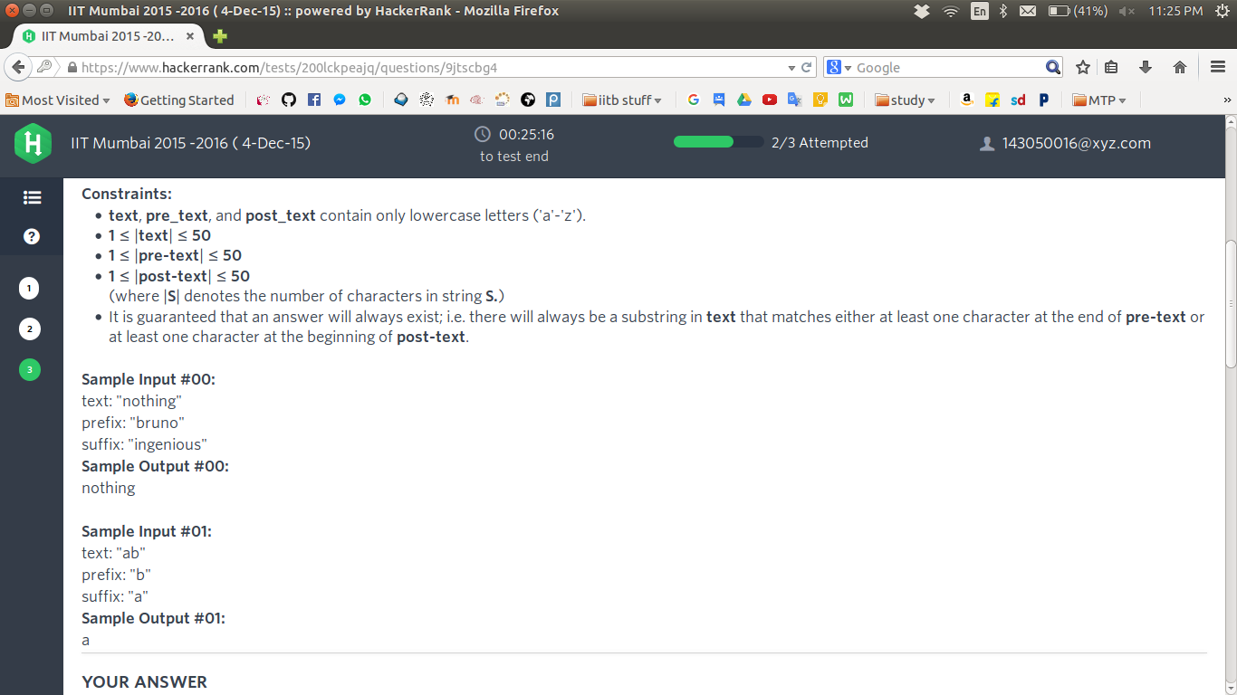**

**In this question the second basic test case is incorrect I think as it clearly mentions to return that substring which maximizes the total as well as is maximal for the prefix score. In that case answer should be “b”. If the total was same for more substrings, and these substrings also had maximal value for prescore, then we would return the lexicographically smallest substring among them.**

**substrings:**

**a prescore=0, postscore=1**

**b prescore=1, postscore=0 //maximal prescore**

**ab prescore=0, postscore=0**

**Anyone GE edison paper for electrical/mechanical ???**